**Name: ABID ALI**

**ID: 2019380141**

**Email:** abiduu354@gmail.com

**◎ Problem:**

Assessing Infection

**◎ Problem Statement:**

**Prerequisites:**

Recursion - Understanding of the concept of a recursive function

•Divide and Conquer - Understanding of the divide and conquer approach to solving a problem

•Vectors - Use of the STL vector container

**Outcomes:**

•Understand recursion

•Understand and apply a divide and conquer approach to solving a problem

The purpose of this assessment is to the understand the recursion method. Similarly, it is to understand and apply a divide and conquer approach to solving a problem.

**◎ Goals:**

This assignment is designed to reinforce my understanding of recursion and problem solving using a divide and conquer approach.

**◎ Structure Chart:**

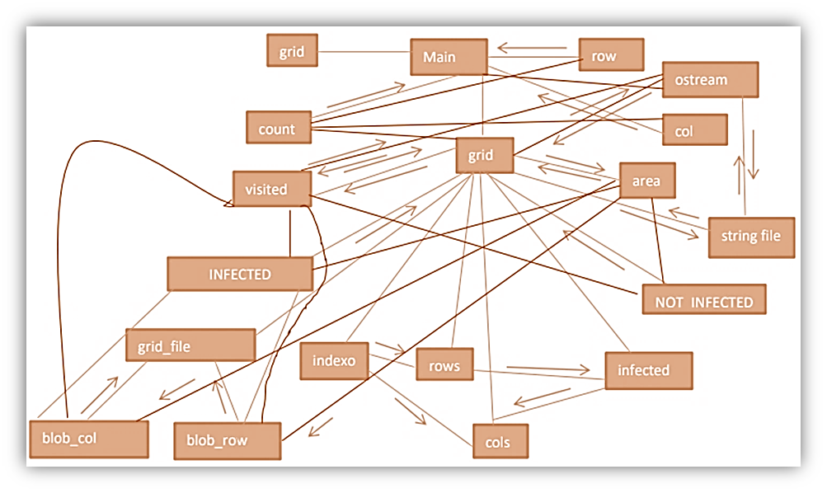

**◎ Implementation:**

**Input: row, col - integers;**

**Output: new index for array;**

**Task: converting two indexes into one for 1-D array in vector.**

#include <iostream>

#include <fstream>

using namespace std;

#include "grid.h"

int grid::indexof (int row, int col) const

{

  return row*cols+col;

}

bool grid::infected(int row, int col) const

{

  return (area->operator[](indexof(row, col)) == INFECTED);

}

**Input: row, col,integers;**

**Output: boolean variable;**

**Task: Saying is cell infected or not.**

grid::grid (string file)

{

  ifstream grid_file;

  grid_file.open (file.c_str());

  grid_file >> rows;

  grid_file >> cols;

  area = new vector<bool>(rows*cols, NOT_INFECTED);

  visited = new vector<string>(rows*cols, "0 ");

  while (true)

  {

    int blob_row;

    int blob_col;

    grid_file >> blob_row;

    grid_file >> blob_col;

    if (grid_file.eof())

  {

        break;

    }

    area->operator[](indexof(blob_row,blob_col)) = INFECTED;

    visited->operator[](indexof(blob_row,blob_col)) = "1 ";

  }

  grid_file.close();

}

**Input: file, string;**

**Task: Filling area array by 0 and 1 from file.**

grid::~grid ()

{

  delete area;

  delete visited;

}

ostream &operator<<(ostream &stream, const grid& ob)

{

  for (int row=0; row < ob.rows; row++)

  {

    for (int col=0; col < ob.cols; col++)

  {

      stream << ob.visited->operator[](ob.indexof(row, col));

    }

    stream << endl;

  }

  stream << endl;

  return stream;

}

int grid::count (int row, int col)

{

    if(0<=row&&row < rows&&0<=col&&col < cols)

    {

        if(infected( row, col)&&visited->operator[](indexof(row,col)) =="1 ")

        {

            visited->operator[](indexof( row,col)) ="1+ ";

            return 1+count (row+1, col+1)+count (row+1, col)+

                   count (row+1, col-1)+count (row, col-1)+

                   count (row , col+1)+count (row-1, col+1)+

                   count (row-1, col )+count (row-1, col-1);

        }

    }

    else return 0;

}

**Task:** Calculate how many cells are infected and are in the one with cell with coordinates (row, col)

**◎ Test Description and Results:**

The following is the result of the assessing infection program. I created a project in the code blocks and added grid.cpp and the result are given below.

**Output:**

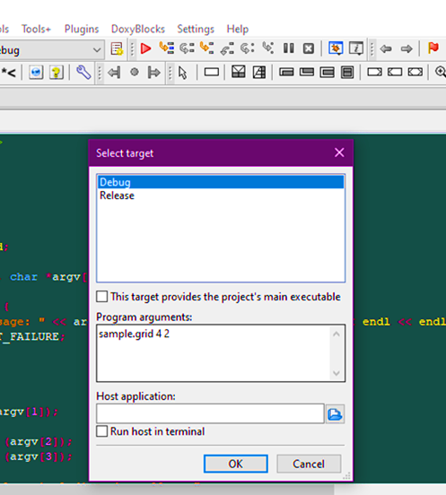

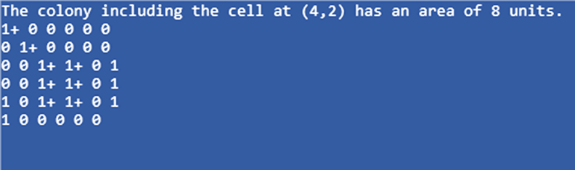

**◎ Epilogue:**

I figured out I had kept the space between row, col and count which occurred problem in running the program. Therefore, I corrected the statement. I had many bugs which had influence on program’s working and many troubles with compilation programs, because of syntax. After checking on the interment I figured out that my syntax was not correct. This program helped me understand the concept of a recursive function. In addition to that, it also helped me to understand and apply a divide and conquer approach to solving a problem like this.

**◎ Attachments:**

grid.cpp

grid.h

**◎ Acknowledgement:**

In the processes of solving this assignment I looked for a lot of information in the internet. I watched several videos related to recursion and took few notes in the process of understanding I discuss with students. I had to search a lot of stuffs in the internet to understand very basics of it. It was a very hard task for me. I have spent many days on doing this.

**◎ Remarks and Grade (by the instructor)**

Instructor Signature:

Grading Date: